Most major change initiatives fail or simply fade over time. How can we discern God’s plans for our ministry? What can we do to make sure that we execute those plans well so they persist over time? In this one-day workshop, we will explain eight proven steps for leading change. The desired outcome is for participants to develop a higher capacity to help their ministry teams discern God’s leading and to implement plans that persist over time. You can register for either the morning sessions that focuses on vision discernment and/or the afternoon session where we will look at a proven method for implementing change in a sustained way.
As a pastor, church planter, missionary, ministry leader, board member and leadership professor, I have had the privilege of helping numerous groups work through a process for understanding and implementing God’s direction for them. It gives me great satisfaction to see individuals, teams and organizations take steps in realizing God’s vision for them.
I earnestly hope and pray that this Vision to Reality training will be helpful as you seek to discern and live out God’s vision for your ministry.

Blessings,
Dr. Randy Wollf
Associate Professor of Practical Theology and
Leadership Studies – MBBS-ACTS Seminaries
MinistryLift Director
Randy@MinistryLift.ca

Kotter’s 8-Step Model for Leading Change
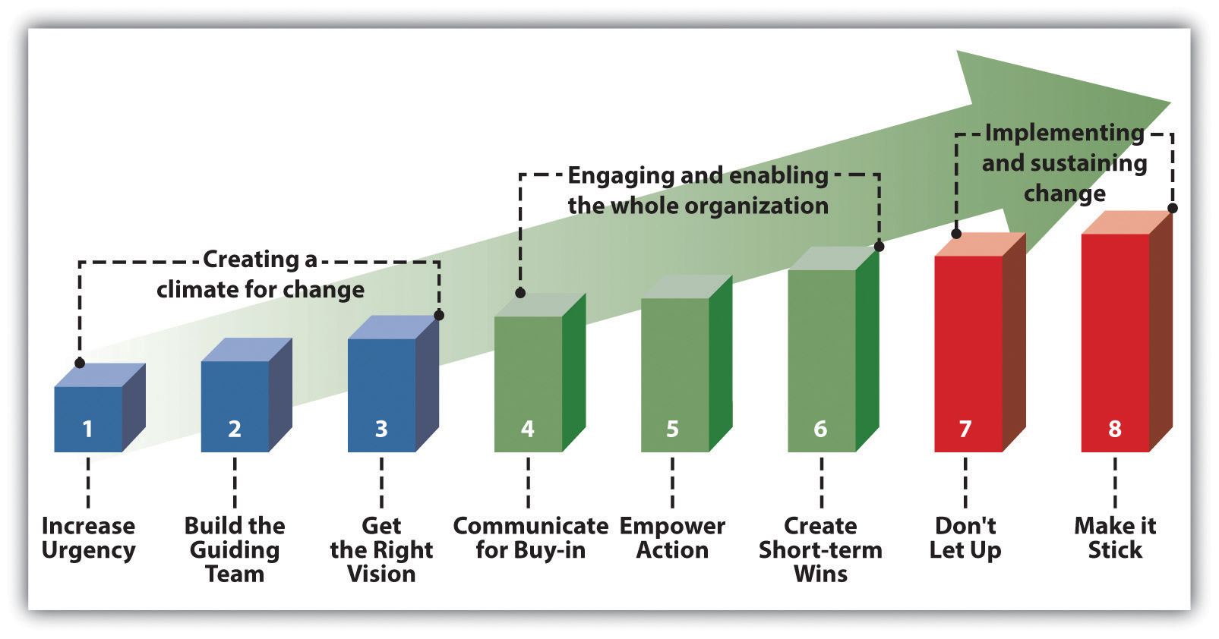
The rest of this training using Kotter’s model as a template, but adapts it and adds to it to make it more useful for churches.
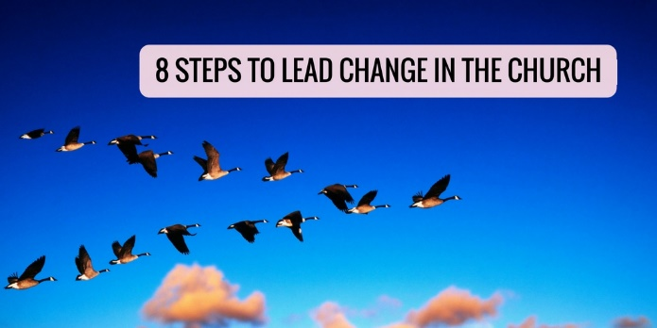
Summary of this adapted approach:
http://ministrylift.ca/8-steps-to-lead-change
YouTube – Search for “8 Steps to Lead Change in the Church”

Step #1 - Increase Urgency
Paying attention to crises and major opportunities while addressing sources of complacency
Discussion – What have you found helpful for building a sense of urgency regarding necessary change?
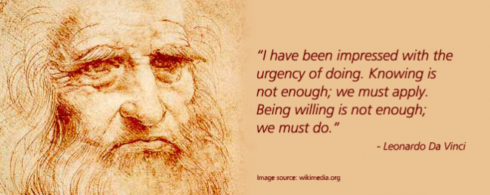
Roger’s Innovation Bell Curve
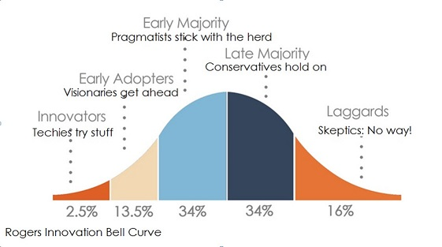

Step #2 - Build the Guiding Team
Pulling together a group with enough power to implement the necessary change and helping them function well as a team
Discussion – How can we have guiding teams who lead the vision discernment process (and its implementation) while still including others in meaningful ways?

Step #3 - Get the Right Vision
Involve as many organizational members as possible in developing a robust vision that captures the heart of the people
Overview of the Vision Discernment and Strategic Planning Process

MinistryLift blog that describes the entire process: http://www.ministrylift.ca/Discerning_strategic_priorities
Characteristics of Effective Vision Discernment and Strategic Planning:
- Prayerful
- Complex
- Collaborative
- Contextually-sensitive
- Participants understand God’s purposes for their lives
- Process-oriented
- Continuous
- Action-oriented
Planning Model Selection
A planning model is the approach you take to discerning vision and developing a strategic plan for your ministry

- Leadership ____________________ (tool – preliminary readiness survey in Appendix A)
- Previous ____________________
- ____________________ level
- ____________________
- Preferences related to ____________________ and ____________________
- Current mission ____________________

Using the following continuums, describe what kind of visioning and planning process would work best in your group?
- Top-down collaborative
- Structured organic
- Point in time ongoing

Mission Identification
Definition
Mission is simply why we exist

Key Questions
- Why did God bring this group together (or why is He bringing us together)?
- What ___________________ resonate deeply with the group?
- What ___________________ and ___________________ do we have within the group?
- What ___________________ might we be able to meet effectively?
- What ___________________ are we well positioned to seize?

Tools for Identifying Mission
- Brainstorm Scriptures that describe our intended purpose as God’s people
- Ask questions that uncover people’s deepest ministry passions and longings
- Use a “Build a mission statement” online tool (e.g. http://www.franklincovey.com/msb/ )
- Come up with adjectives that describe current and desired ministry
Mission Identification Activity
- Write down 3-5 adjectives on separate post-it notes to describe ACTS currently.

- Group these together according to themes.

- Write down 3-5 adjectives to describe your ideal picture of ACTS. Group these as you did with the previous ones.

- Articulate a one-sentence statement of mission based on your sets of adjectives. ACTS exists to...
MinistryLift blog that describes how to create a mission statement http://ministrylift.ca/Creating_a_compelling_group_mission_statement
Scanning the Environment
An environmental scan is an assessment of both internal and external factors that influence or have the potential to influence us as we seek to live out our mission.

Key Questions
- What are our strengths and weaknesses?
- What are the opportunities and threats?
- Which opportunities fit with our mission?
- How can we build on and leverage our strengths?
- What must we do to minimize salient threats?

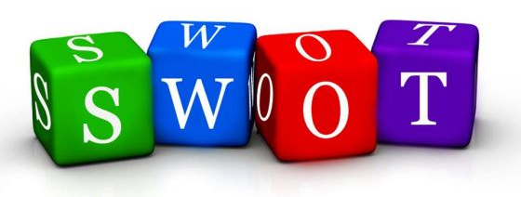
Tools
- Needs assessment
- SWOT Analysis
- Natural Church Development Assessment - http://www.ncdcanada.com/
- Reveal - http://spirituallifesurvey.com/

Ways of obtaining information for the environmental scan include:
- Direct observation
- Questionnaires/surveys
- Consultation with persons in key positions, and/or with specific knowledge
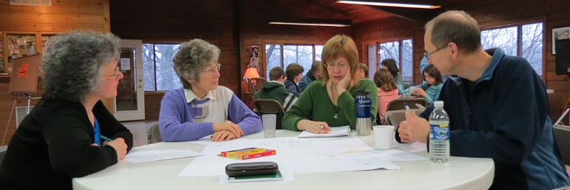
- Review of relevant resources
- Interviews
- Focus groups
- Open forums

Eleven Principles for Conducting Good Surveys
- Clear ____________________
- Every ____________________ connects with purpose
- Keep your questions ____________________ and to the point
- Include ____________________ questions
- Rating scales should be evenly weighted
- Give people advance ____________________
- Do survey ____________________
- Set a ____________________ for survey completion
- ____________________ people about the survey
- Involve others to ____________________ survey data
- Provide a ____________________ of the survey
Check the MinistryLift blog on Writing Excellent Surveys for Your Ministry for more information - http://ministrylift.ca/Tips_for_Writing_Excellent_Surveys.

Group Activity
You are now a focus group looking at ACTS strengths, weaknesses, opportunities and threats. Come up with at least three in each category.
Strengths
Weaknesses
Opportunities
Threats
SWOT

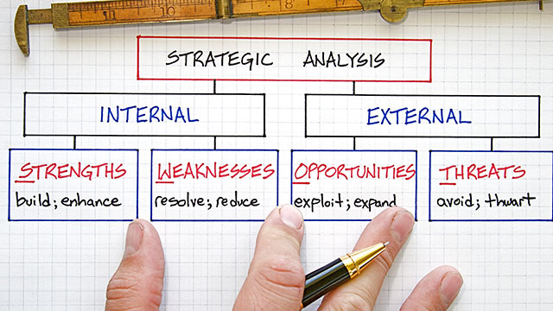
Values Clarification
Values are ideas or beliefs about preferred actions and/or outcomes.
Types of Values
- Low core values – Common habits
- Middle core values – Best practices
- High core values – Highest principles
Tool - Organizational or ministry timeline
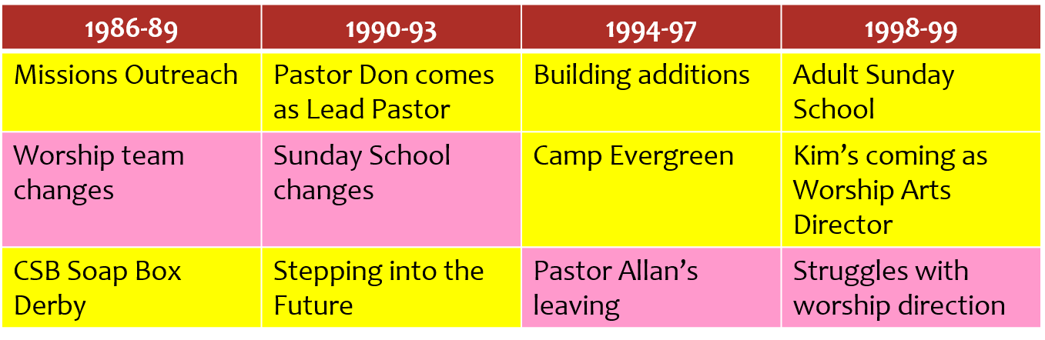
Group Activity
Using the adjectives from the mission statement activity, the SWOT analysis and your own perceptions, come up with 3-5 preferred core values for ACTS moving forward.

Vision Discernment
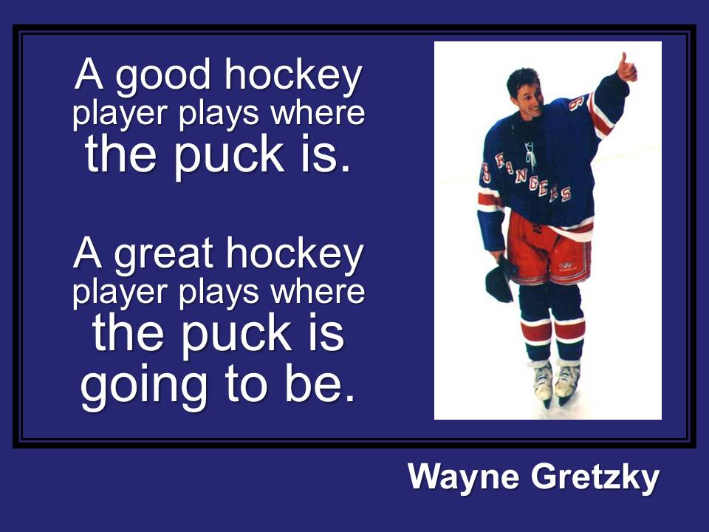
Ideas about Vision
- Vision is first a _______________ and then a set of _______________. It is a sense of understanding intuitively what needs to be done, or a better way of accomplishing something (Matusak, 1997).
Matusak, Larraine R. Finding Your Voice: Learning to Lead-- Anywhere You Want to Make a Difference. San Francisco: Jossey-Bass, 1997.
- “The only thing worse than being blind is having sight with no vision” (Helen Keller).
- Leadership is about keeping “your eyes on the _______________ and your feet on the _______________” (Theodore Roosevelt).
- “A vision is a realistic, credible, attractive future for your organization” (Nanus, 1992, p. 8).
Nanus, Burt. Visionary Leadership: Creating a Compelling Sense of Direction for Your Organization. San Francisco: Jossey-Bass, 1992.
- From a Christian standpoint, vision is a picture of God’s _______________ _______________.
Projecting Yourself into a Preferred Future - It is five years from today’s date and you have, marvellously enough, developed the most amazing seminary at ACTS. Now it is your job, as a team, to describe it - as if you were able to see it, realistically around you.
Using the core values you identified previously, develop a visionary description of how each value has blossomed as part of ACTS preferred future five years from now.

Evaluating Mission Alignment – The Process we went through at South Langley Church
- Affirmed our previous mission statement, core values and vision
- Decided on a process for assessing how we were doing with our five ministry dimensions (worship, discipleship, fellowship, evangelism and service)
- Prepared the congregation
- Developed a survey (both online and on paper)
- Assessed the results (you can see the results here: http://ministrylift.ca/slc)
- Formulated objectives as a church leadership team

Strategic Plan
Definition of Strategic Priorities
These are large strategic initiatives that relate directly to accomplishing your group’s vision.

What can happen if you don’t have a plan (Morgan, 2014)
- The views of the _______________ person will prevail
- You push your _______________ leaders away
- You fuel more _______________
- You need to hold more _______________
- You encourage _______________
- You make it difficult to _______________ what God is doing
- You eliminate the need to _______________ God’s will
- You make it difficult for people to know how to _______________
- You limit _______________ _______________
Morgan, Tony. Developing a Theology of Planning. Amazon Digital Services, 2014.

Examples of Strategic Priorities from South Langley Church
- Encourage and help people become missional in their everyday lives
- Encourage prayer for the unsaved community and how we can best reach the lost
- Serve the community
- Develop better follow-up for existing outreach events/programs

Group Activity
Come up with two strategic priorities that you believe that ACTS needs to focus on to accomplish the vision you identified earlier.

Step #4 – Communicate for Buy-in
Communicating the vision simply and consistently in multiple ways while embodying the vision everywhere

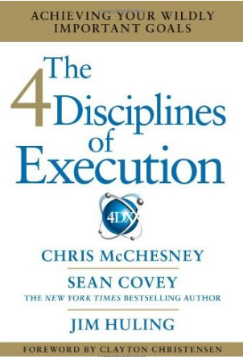
Step #5 – Empower Broad-based Action
Employing a mechanism for insuring that organizational members stay the course over the long-term. The Four Disciplines of Execution is one such mechanism.
You can watch an excellent overview of the Four Disciplines at:
https://www.youtube.com/watch?v=qynXCJZ2xQI.

Discipline #1 - Determine your Wildly Important Goal(s) (WIGs)
A Wildly Important Goal is the most important goal you could set right now to help you achieve your mission.
What is the one area where change would have the greatest ____________?
Focus on ____________ so that your team can achieve more.
_________________ to achieve the WIG will make every other accomplishment seem secondary, or possibly even inconsequential.
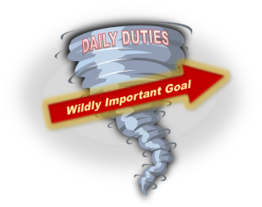
An Example - In MinistryLift, our wildly important goal was to increase participation by 50% (to 1,050 participants) in MinistryLift training events by August 31, 2016
Group Activity
What would be a WIG that you think would have the greatest missional impact at ACTS?

Discipline #2 - Act on the lead measures
Lead measures are steps we can take that will directly influence the accomplishment of our Wildly Important Goal.

The Discipline of Leverage
“It’s based on the simple principle that all actions are not created equal. Some actions have more impact than others when reaching for a goal” (McChesney, Covey, Huling 11).

Lag Measures
- Tells you if you’ve achieved the goal
- You can’t do anything about it
- More visible and easier to obtain
Lead Measures
- Tells you if you are likely to achieve the goal
- It is predictive
- It can be influenced

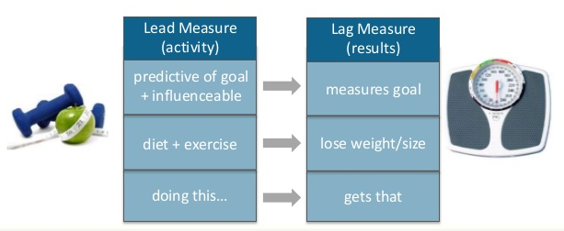
Find high impact lead measures that will drive you toward your WIG

Criteria
- Is it predictive?
- Is it influenceable?
- Is it an ongoing process or a “once and done”?
- Is it a leader’s game or a team game?
- Can it be measured?
- Is it worth measuring?

An Example – MinistryLift Lead Measure of Promotional Touches

Activity
What would be a lead measure that would move ACTS towards accomplishing its WIG?

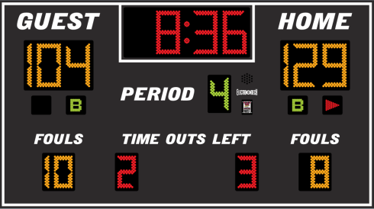
#3 – Create a Compelling Scoreboard
What does a scoreboard do for the players?
A scoreboard should reflect three things:
- Where we are now
- Where we want to be
- When we need to be there

The Principle of Engagement
“In principle, the highest level of performance always comes from people who are ______________ ______________ and the highest level of engagement comes from ______________ __________ ______________ — that is, if people know whether they are winning or losing” (McChesney, Covey, Huling 13).
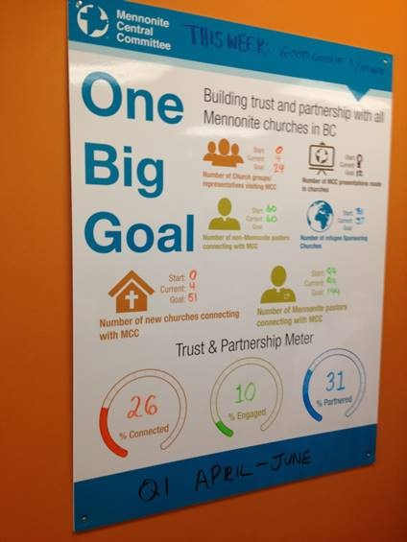
Characteristics
- Big
- Visible
- Continually updated
- Compelling

What to Keep in Mind
- People play differently when ___________________ are keeping score
- A ___________________ scoreboard is not a player’s scoreboard
- The purpose of a player’s scoreboard is to ___________________ the players to win
- “People are most satisfied with their jobs (and therefore most motivated) when those jobs give them the opportunity to experience ___________________” (McChesney, Covey, Huling 75-76).

An Example – MinistryLift Participation

Activity
Design a compelling scoreboard for tracking both lead and lag measures at ACTS.

Discipline #4 – Create a Rhythm of Accountability
The Discipline of Accountability
“It is based on the principle of accountability: that unless we consistently hold each other accountable, the goal naturally disintegrates in the whirlwind” (p. 13).
The SECRET
- “Team members create their own commitments” (p. 13).
- Team members hold each other accountable (p. 14).
“The cadence of accountability is a rhythm of regular and frequent meetings of any team that owns a wildly important goal. These meetings happen at least weekly and ideally last no more than twenty to thirty minutes. In that brief time, team members hold each other accountable for producing results, despite the whirlwind” (p. 13).
Examples of action steps
- Follow-up with Pastor Mark about a regional MinistryLift training event
- Do five tweets and five Facebook posts
- Contact a denominational leader about a MinistryLift membership

Develop SMART Action Steps
- S________________ - Focused on one clearly defined area
- M_______________ - You should be able to chart your progress and know when you have achieved the goal
- A________________ - You should be able to achieve the action step within the stated time frame
- R________________ - The goal should actually help you achieve your overall objective
- T________________ - You should include a completion date so that you have a clear target for completing the goal

Step #6 – Create Short-term Wins
Building momentum by generating noticeable successes that spur on supporters and draw in late adopters and even opponents

Step #7 – Don’t Let Up
Consolidating gains while continuing to explore and execute ideas that will move the organization forward even more

Step #8 – Make it Stick
Anchoring new approaches in the organization’s culture requires open communication and a fierce determination to align actions with the organizational vision and the Wildly Important Goals

